Experiment– Clean Up and Push Back to Remote Git
Objective
- Explain how to clean up and push back to the remote Git repository.
- Execute the steps involved in cleaning up the local repository and pushing the latest changes to the remote Git repository.
- Verify if the Main Branch is in a Clean State
git checkout main
git status
- List Out All the Available Branches
git branch
- Pull the Remote Git Repository to the Main Branch
git pull origin main
- Push the Pending Changes to the Remote Repository
git push origin main
5. Observe if the Changes are Reflected in the Remote Repository
Verified that the latest commits were successfully reflected in the remote GitHub repository after pushing the changes.
Result
The local repository was successfully synchronized with the remote GitHub repository. The latest changes were pulled from the remote repository, pending local commits were pushed successfully, and the updated changes were verified in the remote GitHub repository.
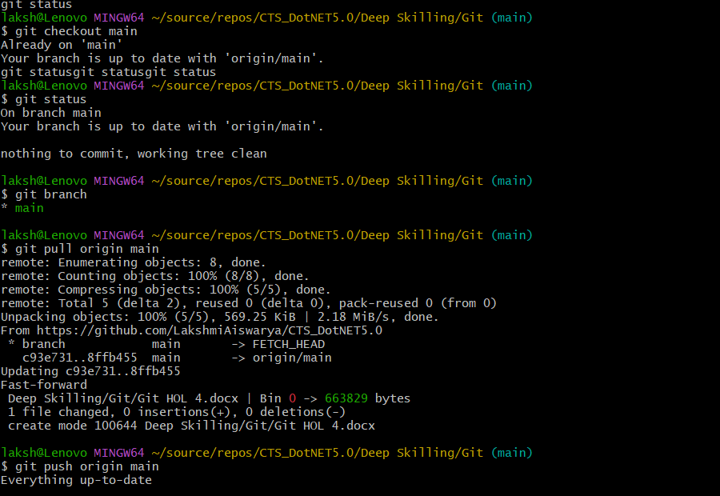
Outputs:

